
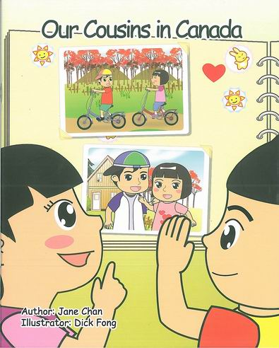
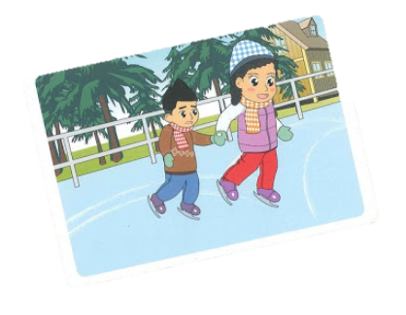
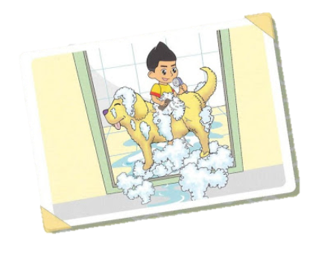
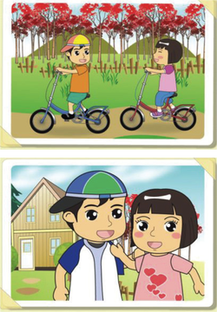
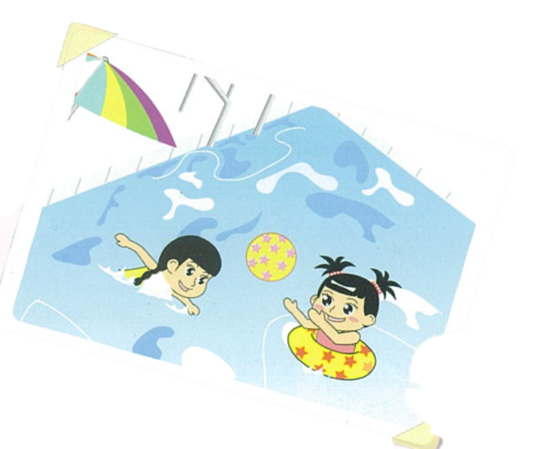
Family Tree

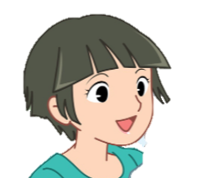

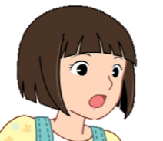
Mum
Dad
Uncle Charles
Aunt Pam




Ben
brother
me
Mandy
Rex
Cherry
uncle
aunt
mum
dad

cousin
cousin
(sister)
Vocabulary
Book vocabulary
 |  | 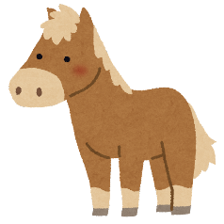 | 
Canada | parcel | pony | plane
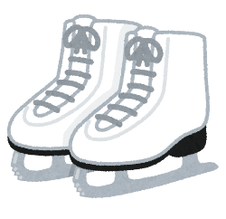 |  |  |   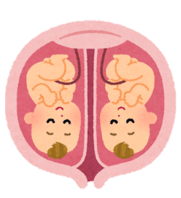
ice-skating | present | 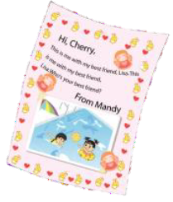  note | twin sisters
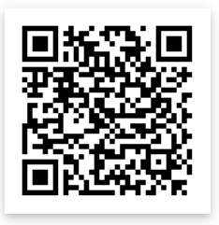

High Frequency Words
= I know how to read and write the word
best |  | black |  | from
these |  | with |  | your



Our Photo Album
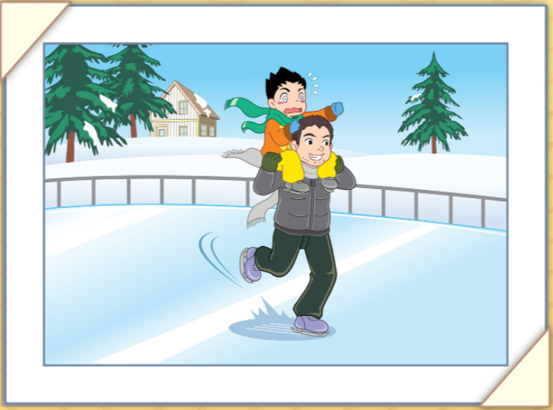
Rex and Mandy are talking about their photos. Help them fill in the blanks.
This is me with my uncle in Canada. We are ice skating. I feel scared!
Uncle Charles
Rex
Rex
e.g.


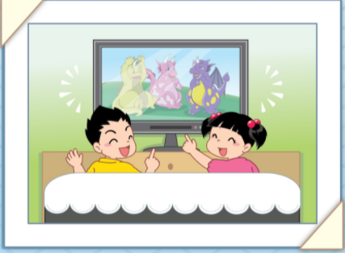
Rex
Mandy
This is me with ( my ) at home. We are ( ______________ _______ ).
I feel relaxed!
Mandy


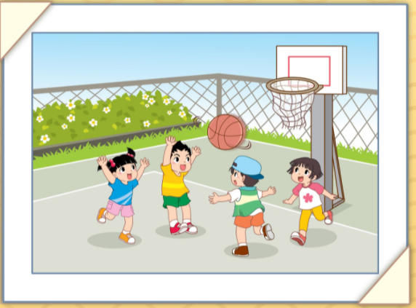
Rex
Mandy
Ben
Cherry
This is me with my brother and ( our ______________ ) in Yau Ma Tei.
We are ( _________ ____________ ).
I feel great!


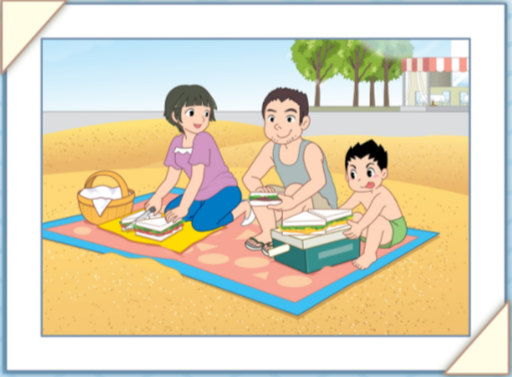
Rex
Mum
Dad
This is me with ( my _______ and my _______ ) at ( _________________ ).
We are ( ________ __ ____________ ).
I feel ( )!



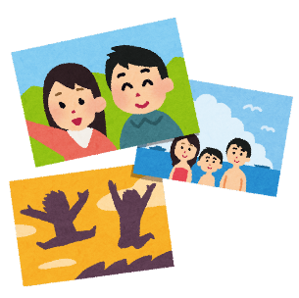
Helpful Words 1
Look at your photos. Use the words below to talk about them.
e.g.
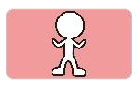  Who | 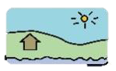  Where | 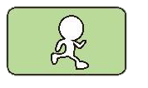  What |   How
Dad  friend  Mum | China  Japan  the swimming pool | eating  playing  swimming | excited  happy  sad

Picture 1
Who | Where | What | How
Mum  Dad  brother  sister  cousin(s) 表兄弟姐妹  relative(s) 親戚  friend(s)  classmate(s)  ___________ |             the beach  China Disneyland  the country park  home  West Kowloon Cultural Centre 西九文化區  Ocean Park  ____________ | 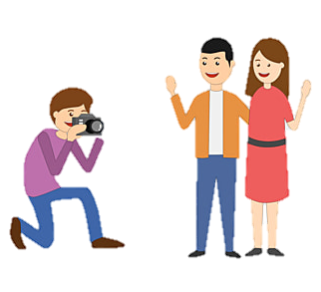  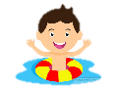  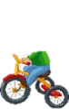      celebrating ____’s birthday 慶祝_____的生日  celebrating my birthday慶祝我的生日  swimming  playing  riding bicycles  taking a photo  _______________ | (happy)  overjoyed        cheerful  joyful  excited  thrilled  wonderful  playful  _________

Picture 2
Who | Where | What | How
Mum  Dad  brother  sister  cousin(s) 表兄弟姐妹  relative(s) 親戚  friend(s)  classmate(s)  ___________ | the beach  China Disneyland  the country park  home  West Kowloon Cultural Centre 西九文化區  Ocean Park  ____________ | celebrating ____’s birthday 慶祝_____的生日  celebrating my birthday慶祝我的生日  swimming  playing  riding bicycles  taking a photo  _______________ | (happy)  overjoyed  cheerful  joyful  excited  thrilled  wonderful  playful  _________
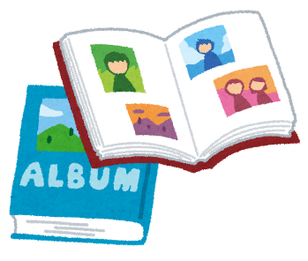
Caption Draft 1
Use your ideas on p. 2 to help you write your photo captions.
e.g.
This is me with my ( e.g. friend )
in / at ( e.g. the swimming pool ) .
I am / We are ( e.g. swimming ) .
I feel ( e.g. happy ) .

Picture 1
This is me / Here I am with my ( ____________________________ )
in / at ( ___________________________________ ) .
I am / We are ( _____________________________ ) .
I feel ( __________________________ ) .

Picture 2
( _____________________________________________________
_____________________________________________________ )
( _________________________________________ ) .
( ________________________________ ) .
Helpful Words 2
Look at your photos. Use the words below to talk about them.
e.g.
Who | Where | What | How
Dad  friend  Mum | China  Japan  the swimming pool | eating  playing  swimming | excited  happy  sad

Picture 3
Who | Where | What | How
Mum  Dad  brother  sister  cousin(s) 表兄弟姐妹  relative(s) 親戚  friend(s)  classmate(s)  ___________ | the beach  China Disneyland  the country park  home  West Kowloon Cultural Centre 西九文化區  Ocean Park  ____________ | celebrating ____’s birthday 慶祝_____的生日  celebrating my birthday慶祝我的生日  swimming  playing  riding bicycles  taking a photo  _______________ | (happy)  overjoyed  cheerful  joyful  excited  thrilled  wonderful  playful  _________

Picture 4
Who | Where | What | How
Mum  Dad  brother  sister  cousin(s) 表兄弟姐妹  relative(s) 親戚  friend(s)  classmate(s)  ___________ | the beach  China Disneyland  the country park  home  West Kowloon Cultural Centre 西九文化區  Ocean Park  ____________ | celebrating ____’s birthday 慶祝_____的生日  celebrating my birthday慶祝我的生日  swimming  playing  riding bicycles  taking a photo  _______________ | (happy)  overjoyed  cheerful  joyful  excited  thrilled  wonderful  playful  _________
Caption Draft 2
Use your ideas on p. 4 to help you write your photo captions.
e.g.
This is me with my ( e.g. friend )
in / at ( e.g. the swimming pool ) .
I am / We are ( e.g. swimming ) .
I feel ( e.g. happy ) .

Picture 3
This is me / Here I am with my ( ____________________________ )
in / at ( ___________________________________ ) .
I am / We are ( _____________________________ ) .
I feel ( __________________________ ) .

Picture 4
( _____________________________________________________
_____________________________________________________ )
( _________________________________________ ) .
( ________________________________ ) .


Christmas Card Draft
Write a Christmas card to a friend or family member.
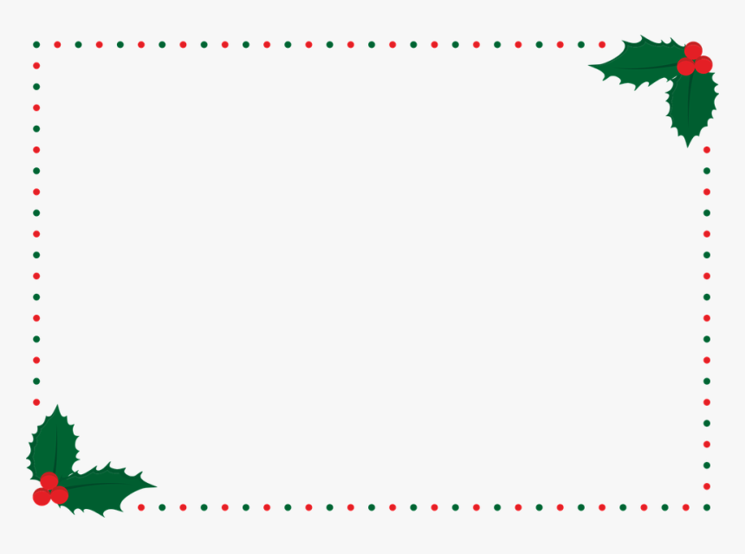
e.g. Dear Mandy,
Merry Christmas and a Happy New Year!
I hope you have a wonderful holiday with your family.
See you next year!
Love,
Ms Lexine

1. Who are you writing to? | Dear ( ________________________ ) ,
2. Greeting | Merry Christmas!  Merry Christmas and a Happy New Year!  _____________________________
3. What do you want to say? | I hope you enjoy your holiday.  I hope you get a lot of presents.  _____________________________________
4. Closing | See you next year!  See you soon!  _____________________________
5. Your name | Love, From, Yours, ________ ,  ( _____________________ )

Phonics

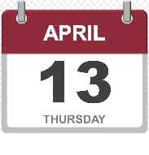
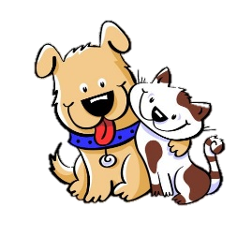
- Read the words. Match the number to the picture.
e.g.
1
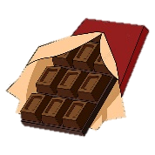
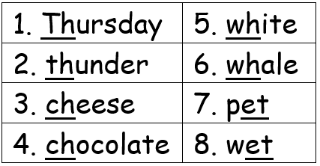



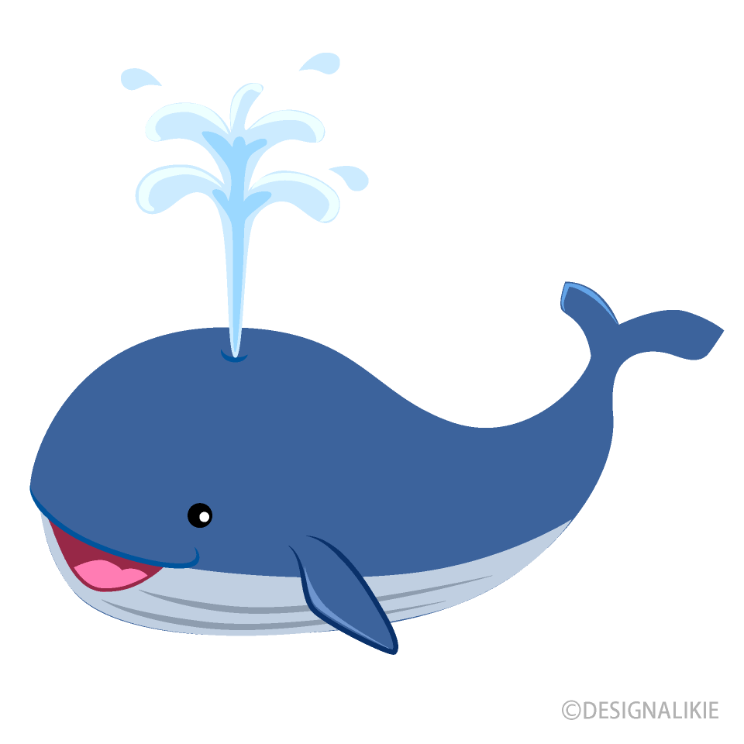
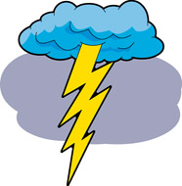

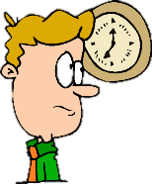
- Circle the sound that matches the picture.
e.g.
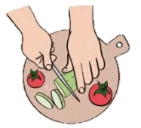 |  |  |  |  | 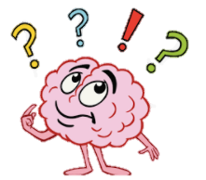
ch | th | sh | ch | th | wh
sh | wh | ch | wh | ch | th

- Read the chants and color the pictures.


thunder on Thursday
th th th
a white whale
wh wh wh
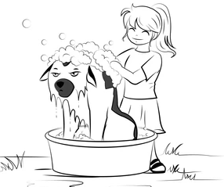
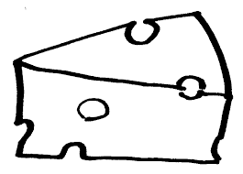
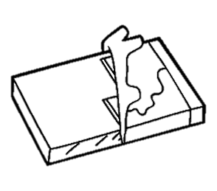
a wet pet
et et et
cheese and chocolate
ch ch ch

Grammar
Fill in the blanks with the correct question word.
  Who | 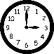  When |   Where |   What |   Why

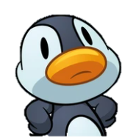
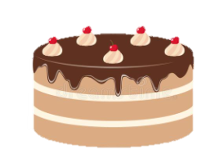
1. ( e.g. Why ) do you have cake?

2. ( _____________ ) do you live?

3. ( __________ ) is your birthday?

4. ( ____________ ) is that?

5. ( ____________ ) is your teacher?
Because it’s my birthday!

I live in Yau Ma Tei.

My birthday is tomorrow.

That is a bird.

My teacher is Miss Chan.

Write sentences using the following words:
- Why: e.g. Why is she sad?
- What: _______________________________________________
- Who: _______________________________________________
- Where: _______________________________________________
- When: ________________________________________________

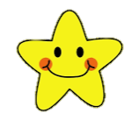


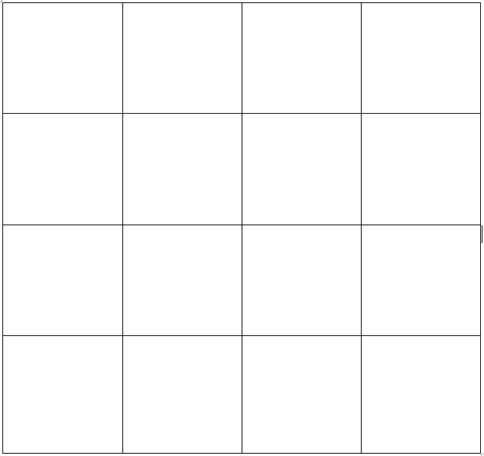

Write down the words. Circle the words the teacher says.
When you get 4 in a row, raise your hand and say:

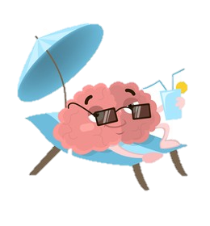

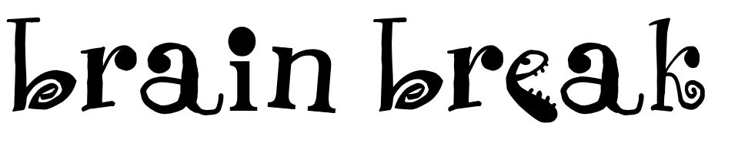


Finished with the worksheet?
Go to the next page for FUN!

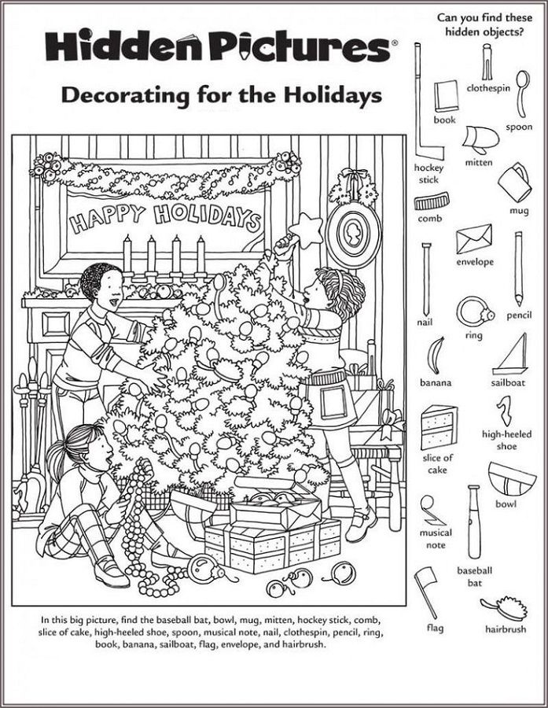


Christmas Present Drawing

Draw what Christmas present you would like to receive this year.

